September 2023 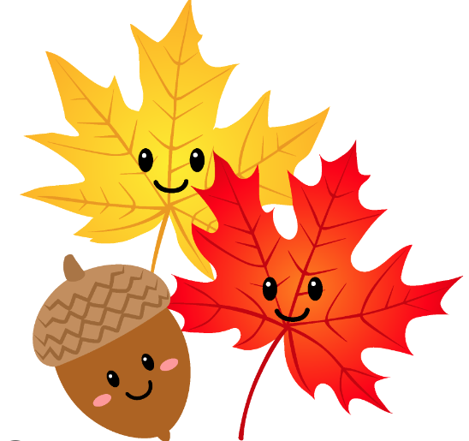
Liberty Neighborhood Center
Monday | Tuesday | Wednesday | Thursday | Friday
Dig September 1
9:30am Hi Morning
10am Tai Chi/Ben
10:30am Emma Nutt
12:30pm Bingo
1:15pm Brain Fitness
Workshop
*Fall Prevention/Safety
4 Center Closed  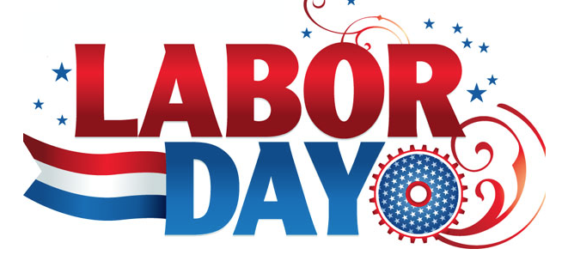 | Football Kick Off 5  9:30am Mingle  10am Exercise your  Pigskin Knowledge  10:30am Force that prevents You from following through  12:30pm Bingo  1:15pm Huddle,Blitz  *Wear team colors  *Paul’s Painting | 6  9:30am meet & greet  10am Volley Ball  10:30am Acts of Random Kindness  12:30pm Tobacco vs Vaping  1:15pm Lizzy the comfort Dog  Picture w/Lizzy@ the  Decorated Tree | Weather Report 7  9:30am Coffee Dear  10am Light n Lively  10:30am Sunshine  Even though there’s (theirs) an overcast  12:30pm Effects of missing a dose of medication  1:15pm Vaccines  *Wear water colors | 8  9:30am Chit Chat  10am Chair Air Ball Welcome to Bring Your Own Ball  10:30am traffic Jams Detours ahead  12:30pm Bingo  1:15pm Wacky Words  *Fall Prevention/Safety
9/11 Day 11  9:30am HEY Friends  10am Forever Young  10:30am Jingo  12:30pm ReSet Your Life Alarm  1:15pm Sing & Dance for lifelong Health | Alzheimer’s Day 12  9:30am Hey Google Play Music  10am Light n Lively  10:30am Alzheimer’s  is not a Normal Part of Aging  12:30pm Bingo  1:15pm Elliptical  Goin Country | Pet Rock 13  9:30am Good Day  10am Hot peppers food & Drug  10:30am Hispanic Heritage History  12:30pm Share Rock collection  1:15pm Where Am I?  *Dress 70’s Fashion | Culture Day 14  9:30am Bomdia  10am Encompass (medical therapy)  10:30am New Moon  12:30pm What Foods to Travel with  1:15pm Portuguese  1500’1800’s Empire  *GROUP BIRTHDAY  CELEBRATION | Lunch & Learn 15  9:30am Hava Java  10am Walkin / Oldies  10:30am Suicide Prevention & Seniors  11am TLC Lecture  12:30pm Bingo  1:15pm Elliptical  *Fall Prevention/Safety
Apple Dumplings 18  9:30am Friendships  10am Pass it on  10:30am My Plate Celebrations  12:30pm Wash Fruit & Veggies Safety  1:15pm Breakfast for Dinner  What’s Cookin? | Grandparents Day 19  9:30am Bonjour  10am Strong Constitution workout  10:30am Best recipes  12:30pm Bingo  1:15pm Sway to Motown  Share & Show | 20  9:30am Sitting Taller  10am The River Yoga  10:30am Foods High in Vitamin C  12:30pm Jingo  1:15pm Where Am I?  5 CLUES | 21  9:30am Chatting  10am light n lively  10:30am Christina (LRMC) Balance Class  12:30pm Oodles of Doodle follow with  1:15pm LNC/ LADH ART SHOWING  *Bring Ur Noodle | Preventions 22  9:30am Chill Pill  10am Stand Tall don’t Fall  10:30am Think like  an Elephant  12:30pm Bingo  1:15pm Ozone  *Fall Prevention/Safety
25  9:30am Buzzworthy  10am Ball Stretches & Strengthening  10:30am Medication management while on vacation  12:30pm Walkin to the 60’s  1:15pm Hidden Picture  *Buddie up Time | Stand Up to Ca 26  9:30am Practice makes Perfect  10am Light n Lively  10:30am Share Your Courageous Stories  12:30pm Bingo  1:15pm Fab 70’s  *Wear Lavender or  * Lavender Ribbon | 27  9:30am Hi Neighbor  10am Volley Ball  10:30am Who Am I?  12:30pm Would You Rather?/Family Feud  1:15pm Where are you now?  * Famous Singers  * Famous Actors | Hidden Treasure28  9:30am A Mate, What’s Your Pirate Name?  10am Walk the Plank  10:30am Kat/Scams  12:30am What’s in your Pirate Booty?  1:15pm Move Grove  *Scavenger Hunt  *Dress like a Pirate | Mayflower Day 29  9:30am Alexa turn it Up  10am 3 rocks from the Sun  10:30am  12:30pm Bingo  1:15pm How Foods Affects Medication  *Fall Prevention/Safety
Highlights:
9/15 TLC Lunch & Learn “Memorials on the National Mall”
Guest Speaker Kasie Alt @11am
Lunch to Follow
Families and Guest Welcome Must Register by 9/7 for lunch orders Contact Chrislene
Birthday;
LeeC.9/6, Gary T.9/20, Sheron S.9/27
Chrislene Nelson-Taylor, Director
Liberty Adult Day
Health Center
800 Tupelo Trail Hinesville, GA 31313 (912) 877-0056
Monday through Friday, 9 a.m. – 2 p.m.
Welcome to Come and Join
Chair Exercises, Crafts ,Fall Colors Art, Bingo Trivia, Games, Music, Puzzles, Guest Speakers, Education
*Activities subject to change. Liberty Adult Day Health clients are welcome to join all activities.

September Happenings
9/1 Lets Dig September Together
Looking at the exciting events planned and making it the best ever for you
Puzzles, cross word, word search, Hidden Picture, crafts are ready to enjoy
Gardening, Craft Corner, Social Circle, Sunshine on the Patio, Walking Club
Fall Prevention Tip 9/1, 9/8, 9/15, 9/22, 9/29
Clutter, Rugs, Ladders, Chairs, Extension Cords, Tubs, Showers, Spills etc…
9/5 Paint in Action with Paul Spence
9/5 Beat or Make Peace with Procrastination
9/5 Celebrate Football Kickoff, Bring your Pigskin Knowledge
Do a little Salsa
9/6 Enjoy Lizzy our fur baby,
9/7 What’s Your Weather Report, sunny or partly cloudy
Dress as to what weather you are, or want to be
9/7 Vaccines South of the Border
9/8 Traffic jam zone, Keeping your roads of life clear
9/11 Gather, Reminisce, Reflect, Share Memories
9/12 Host Andrea Valdez, Your Family Hospice
Alzheimer’s Young Early Onset
The Greatest Known RISK Factor is Increasing AGE
9/14 Little bit of Portuguese, Pouco sobre o portugues
9/14 Abe from Encompass (Medical Therapy)
9/15 TLC/SCI Lunch & Learn Guest Kasie Alt “Memorials on the National Mall
Presented By: THANKS MOM AND DAD FOUNDATION
9/18 Tell us about the Apple of your Eye?
9/19 Bring pics, (Time to Brag) share family and Dessert Recipes
9/12 Share Your Courageous Stories
Let’s Celebrate
9/21 LNC/LADH Doodle ART SHOWING
9/28 Kat Montgomery, Ga Legal Service
Scams Targeting Senior’s
9/28 RRRRR
Dress Like a Pirate,
Get Ready to scavenge for Hidden Treasure,
and
What’s in your Pirate Booty

